**Stroop Effect**

Independent Variable:

Text name and colour are same(congruent) and different(incongruent).

Dependent Variable

Reaction time to read the name of colour in both cases: congruent and incongruent.

Null hypothesis:

µc: Population mean of reaction time to read congruent data.

µi: Population mean of reaction time to read incongruent data.

The population mean of reaction time to read incongruent data is either less than or equal to the population mean of the reaction time to read congruent data i.e.

H0 : µc ≥ µi

Alternative hypothesis:

The population mean of reaction time to read incongruent data is greater than the population mean of the reaction time to read congruent data i.e.

HA : µc < µi

Statistical Test:

A one- tailed paired dependent t-test with alpha level equal to 0.005 is performed instead of z-test because of the following reasons :-

1.Population standard deviation is not unknown.

2.Sample size is less than 30.

3. The sample has approximately normal distribution.

4. Since same group was chosen hence paired and dependence t test will be performed.

Assumptions:

1. Provided are random samples from two independent variables.
2. Populations are approximately normal.
3. Sample data can estimate population variances.
4. Population variances are roughly equal.

t-test will consist of finding the mean of reaction time to both the scenarios. This will be followed by calculating tstatistic . After calculating tstatistic , we will compare it with the tcritical value obtained by t-table.

If tstatistic is calculated to be greater than tcrtical value then , we can assert that we have sufficient information to reject the null hypothesis.

Descriptive Statistics:

Xcongruent = 14.0511

Xincongruent =22.01592

Ncongruent = 24

Nincongruent = 24

SScongruent = 291.3877

SSincongruent = 529.2704

As can be observed in the above graph, both the samples has approximately normal distribution. It can also be observed that line representing the incongruent data is consistently above the congruent one.

Box plot below also states that incongruent has higher values than congruent data.

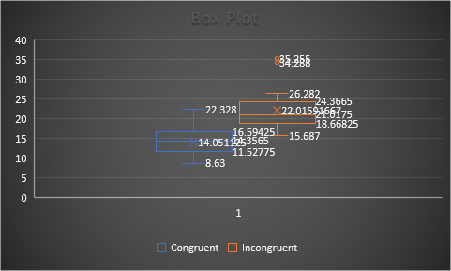

First step to perform one tailed t-test is to calculate tstatistic which can be mathematically represented as below:

tstatistic = (Xcongruent - Xincongruent) / (differenceSD/√n)

where Xcongruent - Xincongruent is our point estimate.

Calculating the difference between the two samples , we can calculate the mean of the difference.

Mean of difference (XD)= Mean((Congruent data – Incongruent data))

XD= -7.96479

Subsequently , we can derive the standard deviation difference as

Sum of the squared deviations difference = Sum of ((Difference between Congruent data and incongruent data )^2)

=544.3304402

Variance = (Sum of the squared deviations difference/(number of samples-1))=23.66654

differenceSD = Square root of (Sum of the squared deviations difference)=4.86482691

Hence , tstatistic = (14.0511 - 22.01592)/( 4.86482691/√24) = -8.02074

Degree of freedom (df) = number of samples -1 = n-1=24-1=23

α=0.005

tcritical = ±2.807

Test Result:

As shown above the absolute value of tstatistic is much greater than tcritical . The negative value of tstatistic confirms that congruent data has less value than incongruent data way beyond the critical value.

Hence , based on the above evidence we can reject the null hypothesis that reaction time to incongruent data has less or equal value than the reaction time to congruent data.

Also p value is less than 0.0001 which shows that this difference is considered to be extremely statistically significant, further supports the argument in favour of rejecting the null hypothesis.